Login System
MFA
Oauth - Backend and FrontEnd
Request management
Dapper vs Entity Framework
Async and Await and their working - Task Notifies the Await and Await will not work on the same thread
Synchronisation context
CORS
Pagination on client side
How we handle heavy load on client side can pagination be done on client side
Idempotency
A circular dependency is a separate initialization issue
Captive Dependency
how aggregate works in Grouping SQL
Stored Procedures
Range Queries helped with Clustered Index
Disposing and Dispose Async
WhenAll and WhenAny - How when all Returns the exception

Class vs Record – Equality and Immutability of only fields and not the new creation of records
ValueTask vs Task – Value task

Multicast Delegate – How Exceptions are stopped propagating after an exception
If all handlers need to executed get all subscriber and try catch each
Boxing and when a value type lives on stack
Semaphores
Mutex
Task and Thread
Authentication vs Authorisation
Synchronisation Context

How to subgroup in C# and give the final answers
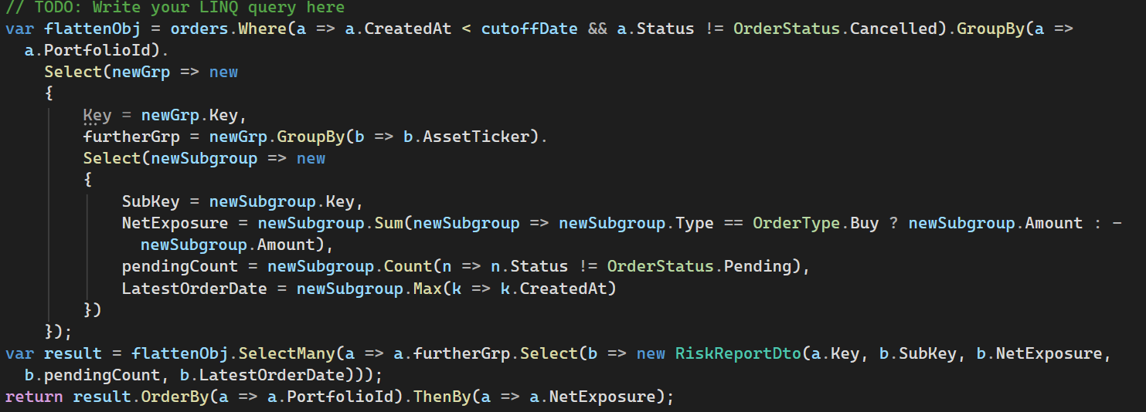

Sargable Queries – Queries which can depend on indexes but it is not index seek
Basically not applying a function on Indexed element.
C.
When the predicate allows the query optimizer to utilize an index seek directly on the raw column without wrapping columns in functions or leading operators.

